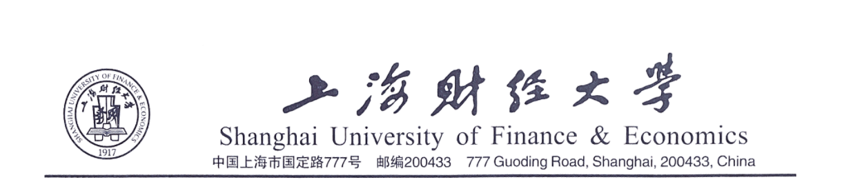
CERTIFICATION
Date: 日期，例：December 12th , 2017
Consulate General of 签证国家
In Shanghai,
This is to certify that Mr. 姓名例：LI Lei (Passport No. 护照号) is 职务，例：a staff member/an assistant professor/an associate professor/a professor of Shanghai University of Finance and Economics. He has been working here for about XX years, since 入校年月，例：July 1993. His annual salary is about RMB 年收入.
He is planning to have a trip to 签证国家 from 出发日期，例：February 14th 2018 to 返程日期. All the expenses including transportation, accommodation, meals, and health insurance will be furnished by himself. He will abide by the laws in your country and will return to China on time. We have approved Mr. 姓名’s leave, and will retain his position. He will resume his duties on his return to Shanghai. The validity of this certification is 30 days.
Name | Title | Annual Salary | Working Years in SUFE | Passport No. | D.O.B
姓名 | 职务 | RMB 年收入 | 财大工作年限 | 护照号 | 生日  例：1990-01-01
Your kind approval of this application will be highly appreciated. If there is any question, please do not hesitate to contact us at 021-65904708.
Yours sincerely,
Contact Person: 胡圆 Yuan Hu
Human Resources Department
Shanghai University of Finance and Economics
Address: 777 Guoding Road, Yangpu District, Shanghai
Telephone：021- 65904708
Fax：021- 65115946

